Exercise 1: Setting Up JUnit
This document covers the steps I followed to complete Exercise 1, where the goal was to set up JUnit in a Java project so I could start writing unit tests.

What I Did
I created a new Maven-based Java project in IntelliJ IDEA called JUnitSetupDemo. Since Maven manages dependencies through the pom.xml file, I added the JUnit 4.13.2 dependency there with test scope, so it's only used for testing and not included in the final build.
The dependency I added to pom.xml:
<dependency>
<groupId>junit</groupId>
<artifactId>junit</artifactId>
<version>4.13.2</version>
<scope>test</scope>
</dependency>

After Maven downloaded the dependency, I created a test class called MainTest inside the org.example package under src/test/java. In this class, I wrote a simple test method testAddition() that checks whether 2 + 3 equals 5 using assertEquals(), along with a couple of print statements to confirm the setup was working.

Test Code
The final MainTest.java file looks like this:
package org.example;

import org.junit.Test;
import static org.junit.Assert.assertEquals;

public class MainTest {

@Test
public void testAddition() {
System.out.println("JUnit is set up successfully! Running testAddition...");
int result = 2 + 3;
assertEquals(5, result);
System.out.println("Test passed: 2 + 3 = " + result);
}
}

Running the Test
I ran the test directly from IntelliJ IDEA, and the Run panel confirmed everything worked as expected:
- MainTest.testAddition() shows a green checkmark
- The summary reads "1 test passed"
- The console printed "JUnit is set up successfully! Running testAddition..." followed by "Test passed: 2 + 3 = 5"
- The process finished with exit code 0
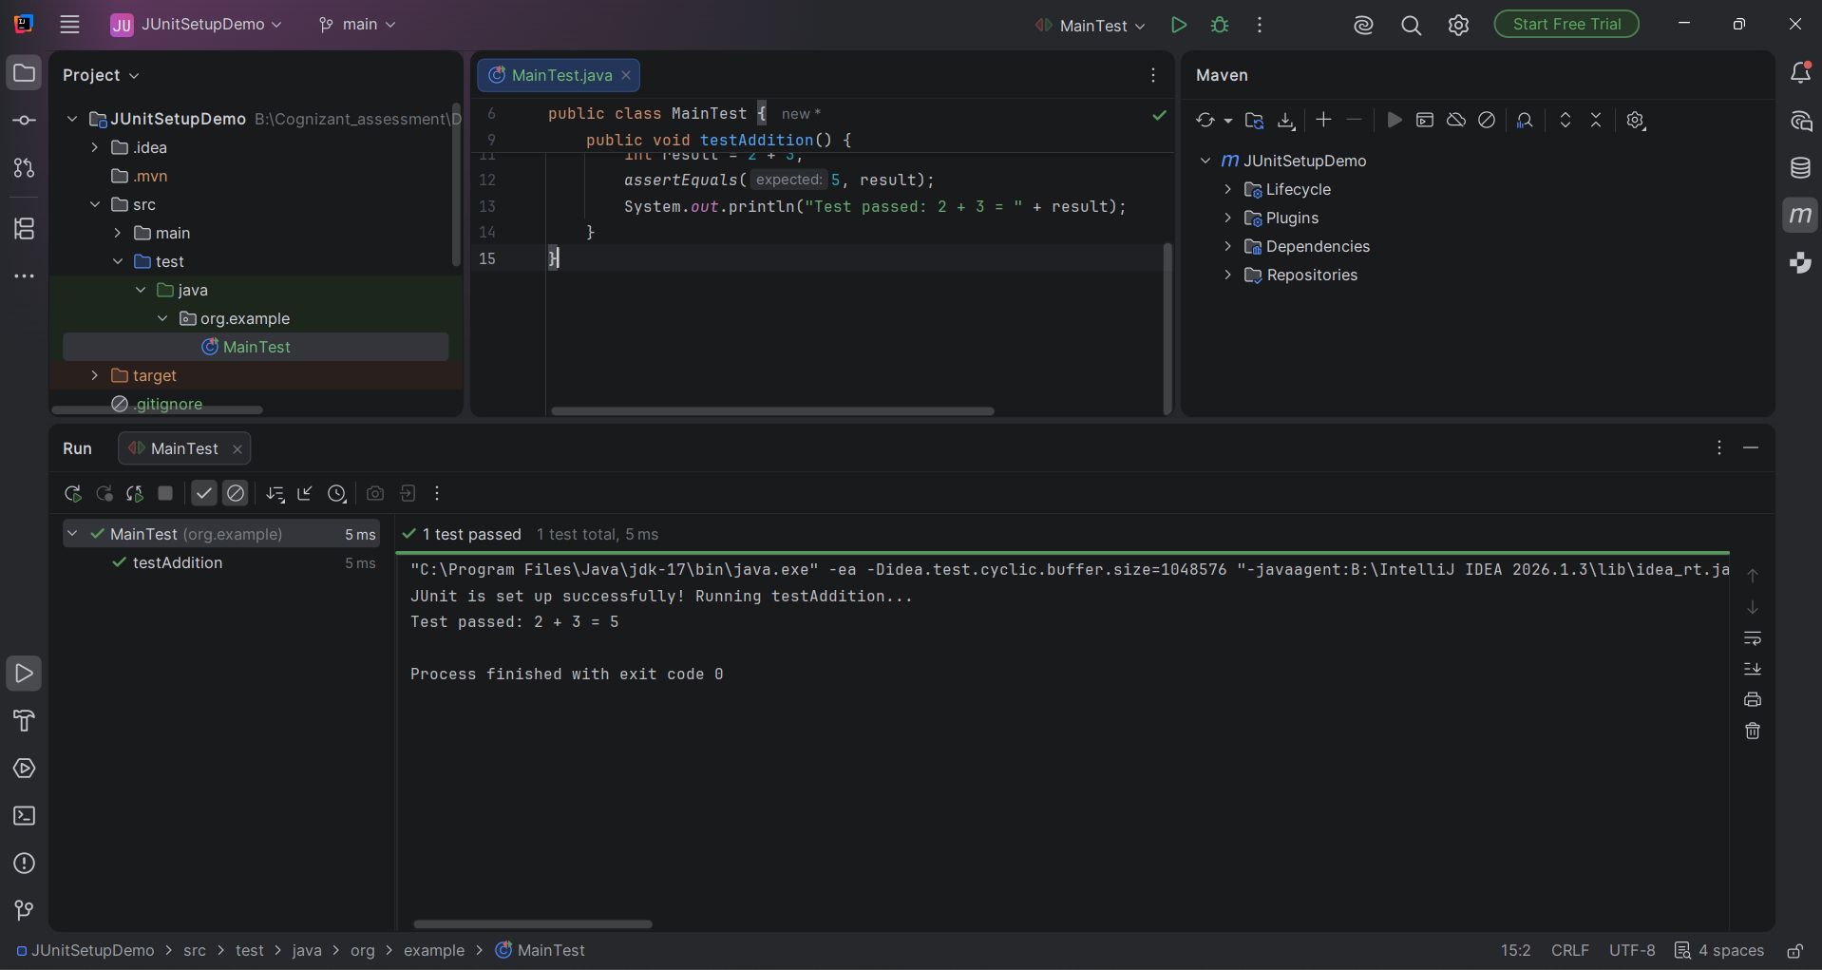

Result
JUnit was successfully set up in the project, and the sample test ran and passed without any issues. This confirms the environment is ready for writing further unit tests, and completes Exercise 1 successfully.

